A000-Indo-Irian Jaya-Biak Island, Cenderawasih Bay-*Korwar*-with Skull Container-late 19th century.

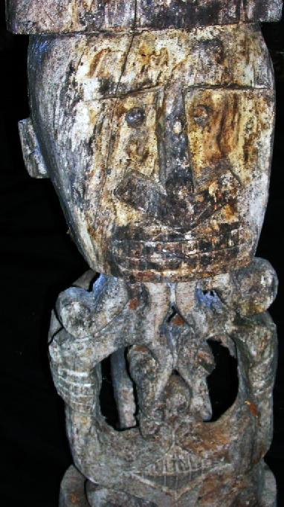 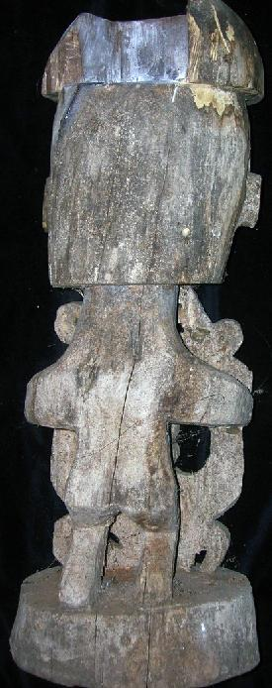 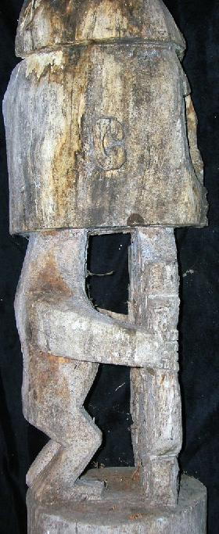

Figs. 1-3. Indo-Irian Jaya-Biak Island, Cenderawasih Bay-*Korwar*-with Skull Container-late 19th century.

Fig. 2-3 shows the human skull emplacement structure at the top of the sculpture.

Case no.: Oceania

Accession Number:

**Formal Label:** Indo-Irian Jaya-Biak Island, Cenderawasih Bay-*Korwar*-with Skull Container-late 19th century.

**Display Description:**

*Korwar* ancestor figure, sculpted in wood, Cenderawasih Bay, NW New Guinea. The unspoiled island of Biak is located in the Cendrawasih Bay of Papua (Irian Jaja), west of Papua new Guinea. Biak island itself is the biggest island in the Biak-Numfor regency with 1.898 square km area. The entire area of the regency is 3.130 square km which has a total 67 islands. Each island is surrounded by a pristine white sandy beach with the breath-taking shallow coral reefs and magnificent deeper coral gardens. The water about 30°C is usually calm with visibility exceeding 50m (150ft).

This locality is distinguished by elaborate ancestor worship in which religious specialists carved *Korwar* figures portraying the deceased as an intermediary that allowed family units to communicate with the dead. The last skillful *Korwar* carvers in Biak about 1880 kept a large collection of *Korwar* and other artifacts until Christian missionaries converted the Papuan inhabitants and destroyed traditional figures such as this. This figure was designed for actual ceremonial use and was not produced as an art object for collectors: hence it has anthropological and ethnological value unlike art imitations in many art institutions.

The Melanesian Austronesian -speaking peoples of the coasts and islands of Cenderawasih Bay in northwest New Guinea formerly created Korwar figures that portrayed recently deceased ancestors in which the skull of the deceased was placed over the head of the figure so that the *Korwar*'s eyes could peer out through the skull's orbits. Korwar images served as supernatural intermediaries, allowing the living to communicate with the dead, who remained actively involved in family and community affairs. When a family member died, relatives summoned a carver, typically a religious specialist, who created a Korwar and enticed the spirit of the deceased to enter it.

One aspect of this endeavor was to have the skull of the deceased implanted in the *Korwar* figure to enable this communication to transpire. The skull repository is a critical structure of the *Korwar* sculpture often missing in those sculptures made for the tourist market often found in examples in museums! The religious specialist who carved the *Korwar* statue was intimately familiar with the deceased and the deceased’s family so that essential traits could be incorporated into the finished sculpture. Since the use of skulls for this purpose was banned at the beginning of the last century at the request of the mission by the Dutch government in Biak, and since this *Korwar* has the skull emplacement cavity , this *Korwar* is probably from the late 19th c.

Despite these individualized aspects of the *Korwar sculpture, Korwar* sculptural imagery was conventionalized, which depicted the ancestor in a seated or standing position with a prominent head and skull emplacement structure, which is the basis of decision–making, and an arrow-shaped nose that distinguished the ethnicity of the Cenderawash people.

Emplacing the skull of the deceased into the skull repository of the *Korwar* sculpture is the most important ceremony. After emplacing the skull the ceremony of enticing the deceased to enter the statue takes place and continues until the spirit was felt by the family group to be at home in its new environment.

Prior to important family decisions the *Korwar* would be consulted as to the proper course of action, and these decisions could range from the mundane to those affecting the whole family unit. In each of these decision-making ventures the religious specialist would be summoned to lead the family group in summoning the deceased’s spirit and petitioning it to respond to the petition. In these group gatherings furtherance of family ties was socially and psychologically strengthened.

One critical aspect of the *Korwar* ceremony is that if the advice provided by the *Korwar* proved bogus in the eyes of the family unit, the *Korwar* could be retired from service, sometimes even violently destroyed. This action provides an important aspect of the psychological dependence on the *Korwar,* in that family consensus as to the proper action to be taken was the real issue and this petition to the deceased appears to have been rooted in knowledge of what the deceased would have wanted for the good of the family unit.

**LC Classification:**

Date or Time Horizon: late 19th–early 20th century.

Geographical Area: Irian Jaya-Cenderawasih , Geelvink Bay

**Map, GPS coordinates:**

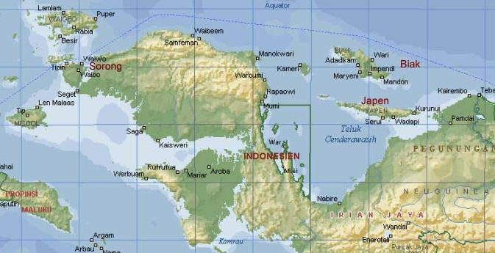

Biak caves, on the island of Biak, Indonesia. Location Lat 1° 0' 0S Long 136° 0' 0E Biak Island is located to the north of the New Guinea mainland. To the south is Geelvink Bay.

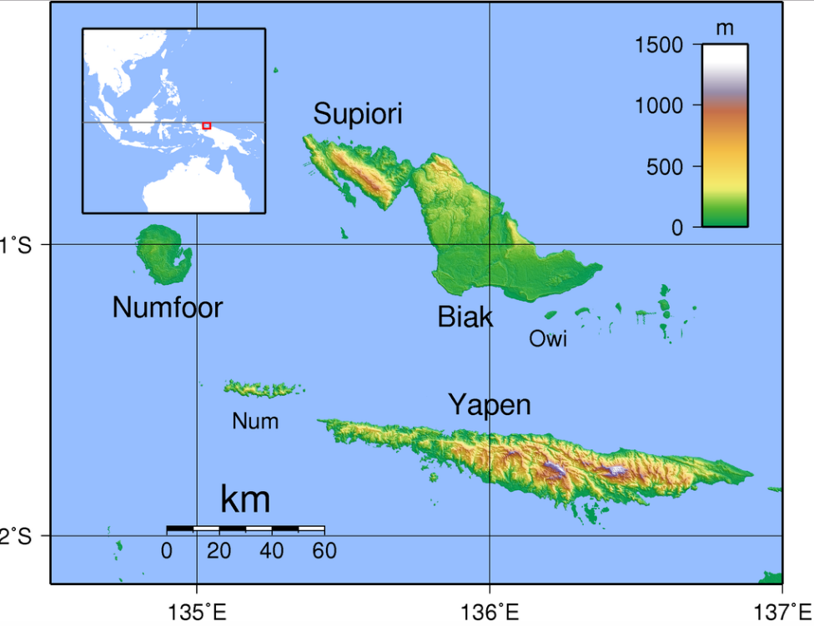

Biak Island in Cenderwash Bay, New Guinea after By Sadalmelik - Own work, Public Domain, <https://commons.wikimedia.org/w/index.php?curid=2218426>

**GPS coordinates: 1o S, 136o E**



Trail map to the none cave systems where Korwar sculptures have been found hidden from the authorities and missionaries. Sketch of a map at the entrance to the trail system 1998, entitled “Biak na Bato National Park”.

Cultural Affiliation: Biak Island

Media: wood, human skull

Dimensions: H 22 in minus the human skull

Weight:

Condition: original. Lacking one eye piece.

**Provenance:** showing evident patina of age. This *Korwar* comes from a large ethnographic collection acquired by the Bouck Estate, New York City, in 1944.

**Discussion:**

This figure was excavated from Biak Cave on Biak island prior to 1942 when the Japanese invaded the island and desecrated the interior. The cave was finally burned with gasoline by Allied Forces in 1944.



Biak, Manngning Cave c 1950 after http://pwencycl.kgbudge.com/images/B/Biak__east_caves_full.jpg

Because this figure shows great patina it must date from the late 19th or early 20th century as a ceremonial object.

**References:**

Baaren, Th. P. van, *Korwars and Korwar Style;* *Art and Ancestor Worship in North-West New Guinea.* The Hague, 1968.

Duuren, D., "An old *Korwar* from New Guinea in Amsterdam's Tropenmuseum", in:. *Tribal- the magazine or tribal art* IX-1, No. 34, Spring 2004, pp. 110-113.

Kooijman, S., 1969. *Korwar*s and *Korwar* style. Art and ancestor worship in North-West New Guinea. Art in its context. Museum series: volume 2

Schmitz, C.A., 1956. Style Provinces and Style Elements: A Study in Method. *Mankind*, *5*(3), pp.107-116.

Smidt, Dam, "*Korwar*s: striking images as mediators between the living and the dead", in M. Holsbeke (ed.), *The object as a mediator;* *about the transcendent meaning of art in traditional cultures.* Antwerp: Ethnographic Museum City of Antwerp, 1996, pp. 68-77.

Van Baaren, T.P., 2010.*Korwars and Korwar style: Art and ancestor worship in North-West New Guinea*. Walter de Gruyter.